**DROPSHIP REPORT**

**FINANCIAL METRICS**

**Gross Merchandise Value:**

|  |  |  |  |
| --- | --- | --- | --- |
| **Serial Number** | **Price (P)** | **Quantity (Q)** | **P*Q (INR)** |
|  | 5000 | 1 | 5,000 |
|  | 1100 | 67 | 73,700 |
|  | 900 | 4 | 3,600 |
|  | 700 | 2 | 1,400 |
|  | 400 | 11 | 4,400 |
|  | 300 | 2 | 600 |
|  | 250 | 2 | 500 |
| Total Gross Merchandise Value | | | 89,200 |

**Revenue:**

Revenue from Hostel Orders: INR 13,300

Revenue from Facebook & Instagram: INR 28,550

Revenue from WhatsApp Groups: INR 40,000

TOTAL REVENUE: INR 81,850

*Notes:*

*Breakdown of Pending Payments of orders:*

*Revenue from Hostel Orders: INR 5000*

*Revenue from Facebook & Instagram: INR 25,700*

*Revenue from WhatsApp Groups: INR 11,000*

**Costs:**

Idols (Purchases): INR 55,325

Instagram & Facebook Marketing: INR 2,350

*(Ads + Reels + Collaborations)*

Posters for Offline Marketing: INR 280

Logistics & Operations: INR 1,952

*(Travel + Delivery + Packaging)*

TOTAL COSTS: INR 59,907

**Profit:**

Total Revenue – Total Costs

= INR 81,850 – INR 59,907

= INR 21,943

**FINANCIAL RATIOS**

**Customer Acquisition Cost:**

Total expenses to acquire customers/total number of customers acquired

= INR 2,630/25

= INR 105.2

**Conversion Rates**

Facebook & Instagram Ads Performance:



Total Amount spent (Ads only): INR 821  
Number of Ads: 2

Reach: 15,308

Impressions: 23,622

Cost per lead: INR 17.85

Converted: 2

Customer Acquisition Cost through Facebook /Instagram: INR 411

**Overall number of leads through Facebook marketplace listing, WhatsApp groups, resharing of stories, word of mouth: **170+**

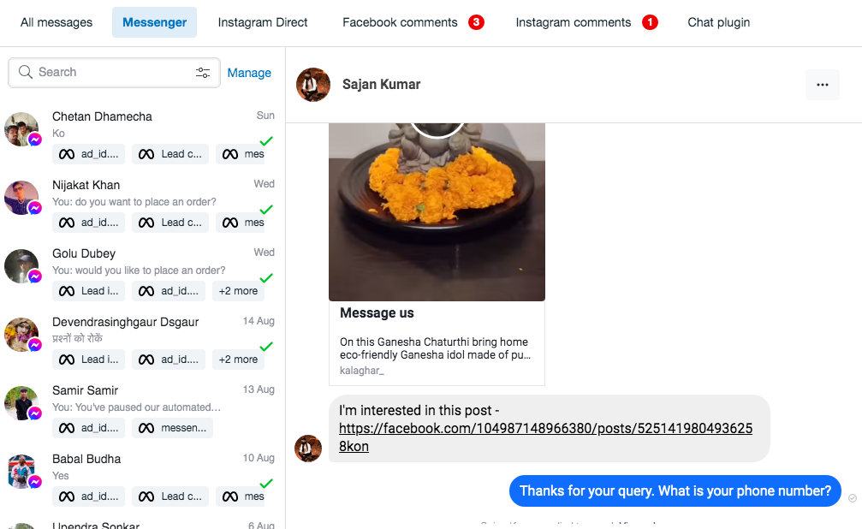

Number of conversions from Whatsapp groups, Facebook marketplace listing: 3

Number of conversions through dropshipping mela at hostel: 20  
Cost of acquiring customers through dropshipping mela: 280/20 = 14

**PRODUCT METRICS**

**Number of SKUs:** 10

**Number of units sold:** 89

**Number of customers:** 25

Our products:

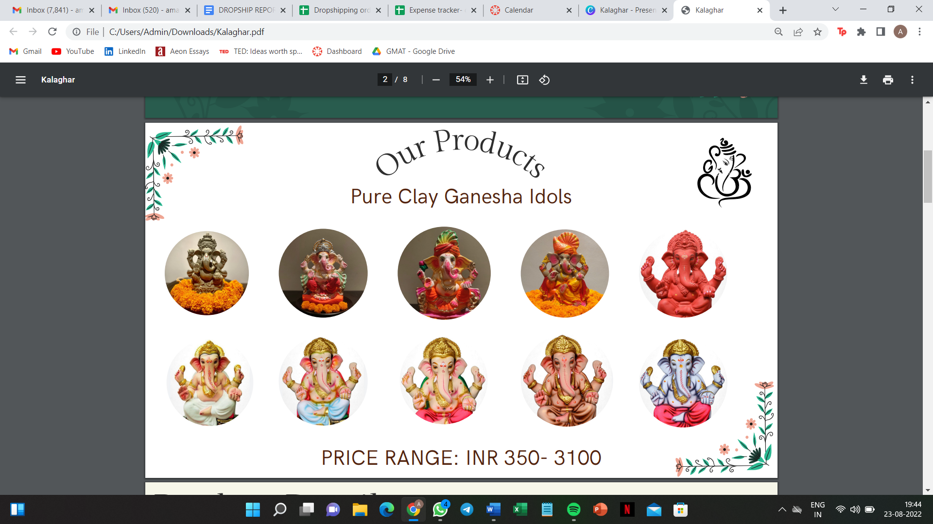

**MAJOR INSIGHTS**

1. Since religious sentiments are involved, there was a high requirement of ***customization***.
2. Since this was a ***specialty*** good, *time-specificity* mattered for both orders and delivery.
3. Since, we saw our cohort as a partying bunch rather than religious, we initially marketed the idols in the hostel, so that students could order for their homes. However, lot of students also bought the idols for their rooms. Therefore, we learnt that debauchery and religion ***aren't*** necessarily mutually exclusive.
4. People associate with the traditional buying process with ***local*** ***vendors***, so shifting online is a challenge.
5. Issues establishing ***trust*** - Lot of potential customers were concerned regarding packaging and delivery since the idols are ***brittle.***

**MARKETING CAMPAIGN**

Our marketing campaign revolved around the main selling point of our idols- OUR IDOLS IMMERSE IN 10 MINUTES.

SNIPPETS OF OUR MARKETING CAMPAIGN:

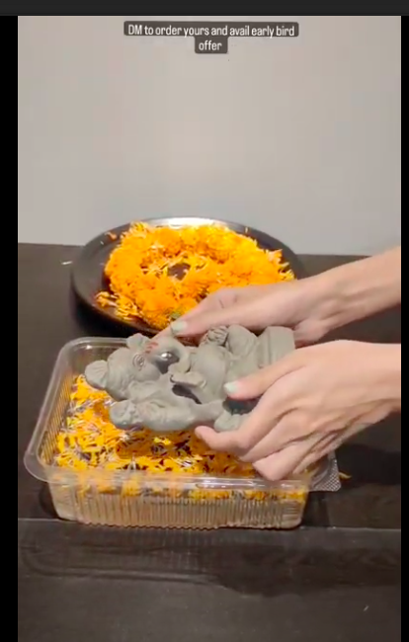 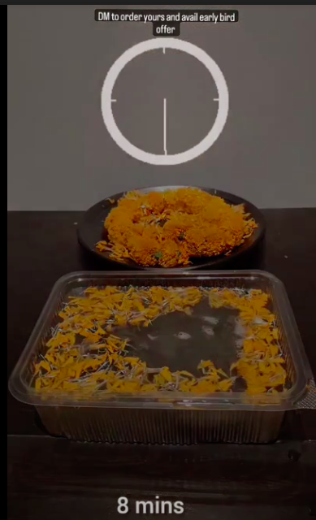

LINK TO OUR MARKETING CAMPAIGN: <https://www.instagram.com/kalaghar_/reels/>

REACH OF THIS CAMPAIGN: This reel went viral with ~9400 views within 1.5-2 weeks of our Instagram page being operational.

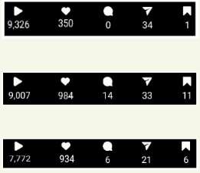

Couple of other reels also **got extremely high traction**:  
Snippets:

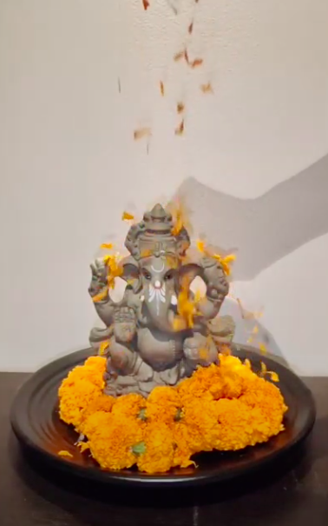 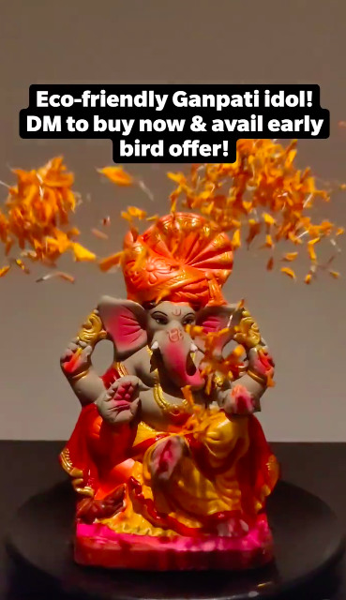

**Links:**

[**https://www.instagram.com/reel/CgPVWQdpJzd/**](https://www.instagram.com/reel/CgPVWQdpJzd/)[**https://www.instagram.com/reel/CgZdE1ZJyW0/**](https://www.instagram.com/reel/CgZdE1ZJyW0/)

**Reach:**



**Instagram collaboration:**

Collaborated with forever ecostore for a shoutout on their page, which is an Instagram page promoting eco-friendly products.



**FINANCIAL REPORTS**

**Profit & Loss Statement:**

|  |  |  |  |
| --- | --- | --- | --- |
| **Particulars** | **INR** | **Particulars** | **INR** |
| Purchases | 55,325 | Sales | 81,850 |
| **Gross Profit** | **26,525** |  |  |
|  | **81,850** |  | **81,850** |
|  |  | Gross Profit | 26,525 |
| Marketing Costs | 2,630 |  |  |
| Logistics & Operations | 1,952 |  |  |
| **Net Profit** | **21,943** |  |  |
|  | **26,525** |  | **26,525** |

**Balance Sheet:**

|  |  |  |  |
| --- | --- | --- | --- |
| **Liabilities** | **INR** | **Assets** | **INR** |
| Capital | 59,907 | Cash/Bank | 40,150 |
| Net Profit (P&L A/c) | 21,943 | Debtors | 41,700 |
|  | **81,850** |  | **81,850** |

**BANK STATEMENTS**

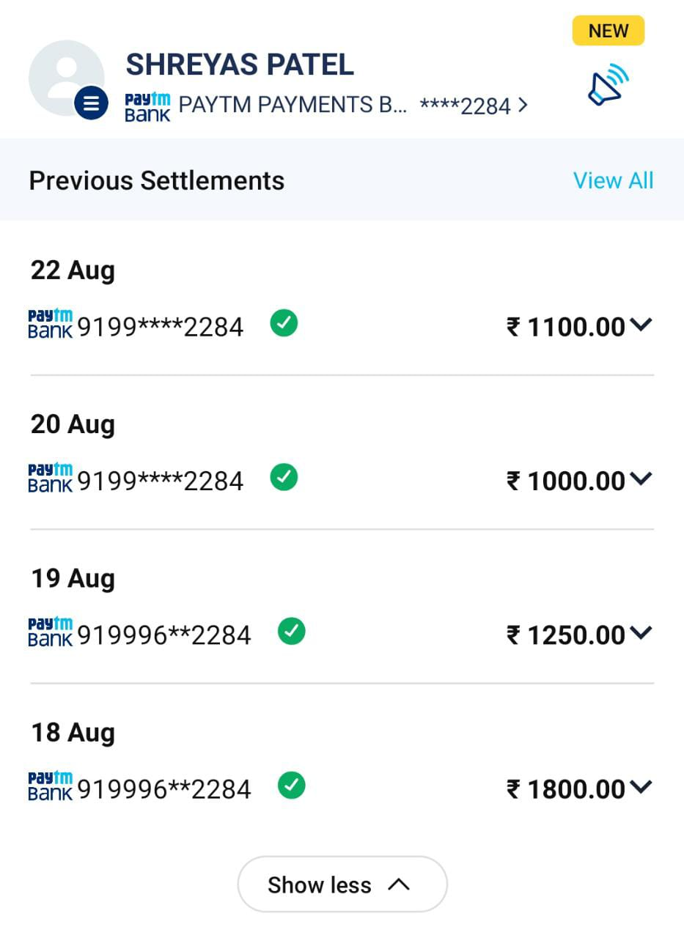

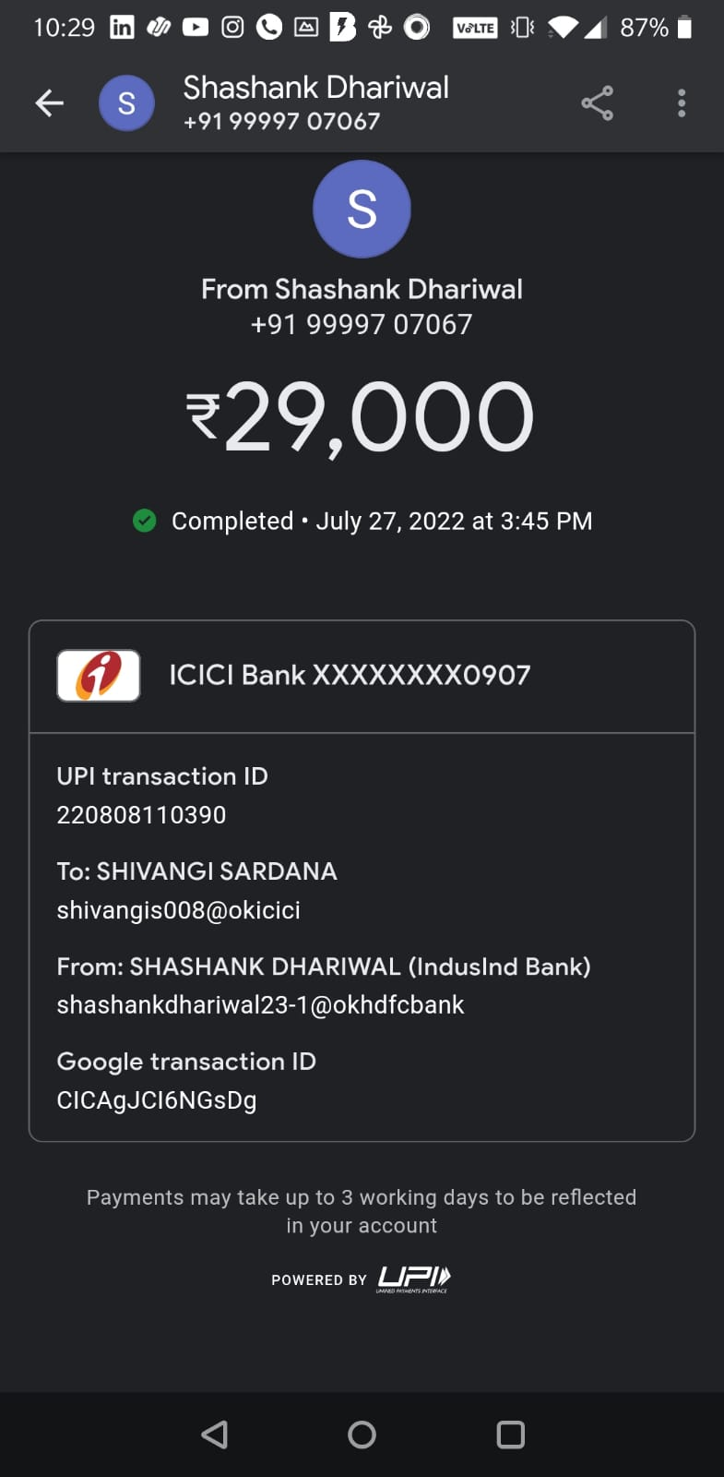

***Received payments of INR 6000 through cash.***